First time setup:
- Set up your desired file directory structure, do what you think will work best on your system, but I suggest a subfolder for code/, a subfolder for logs/, and a subfolder for other information, like intro/
- Take USER_QUICK_START.md and feed it into your LLM of choice (you should also read it, of course). Prompt it to make you a wrapper to run this on a given Kaggle competition and buggy/debugged code file name of your choice and structure. You need to provide your User ID and your token (get these from Sarang).
- Your goal is to be able to just run something from the command line that submits the job to the GPU server, like ./api_run.sh (or a Python script or whatever works).
- If set up properly, when you run scripts, you’ll get an output log like the one below:
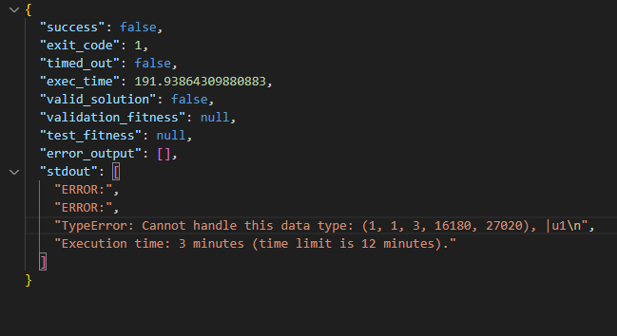

Running buggy or debugged code:
- Make sure your name is on the row and you’ve marked the row in some visible way to indicate you are working on it.
- Submit your code via your API wrapper to run on the GPUs with whatever expected_time you have set. I suggest 10 minutes (though it’s in seconds, so 600 seconds).
- If a bug is thrown, fix it in a new file as:
<competition-name>_<datarow-id>_<debug_step>.py
or some similar naming convention that helps you keep track of your things
- After each bug is fixed, write a paragraph-based analysis in natural language (no need to be extremely overly technical, but at least be specific, such as quoting specific line numbers) in the revised_analysis column of your row. Do not reference the client’s original analysis/plan, as this could be erroneous.
Also, write in the revised_plan column in markdown format matching the example below, but with how ever many items in the numbered list you need to describe a plan for fixing your bug you encountered. Otherwise, keep the same “**Bug Fix Plan**” header you see here and the same numbered list format. Line numbers are great to include for specificity.
- Take your output at ~/buggy-nodes/logs/<file-name>.jsonl for the run you just finished and paste its contents into the output_logs_after_fix column. Paste your full code that fixes the bug into the current_debug_code column.
- When you’re doing fixes, always ensure that your fixes are as MINIMAL as possible. You should rarely if ever do a complete overhaul of the code, aim for minimal fixes.
- If you fixed a bug, but then a NEW bug pops up that is unrelated to the initial bug, i.e., the first bug was “hiding” the second bug (and the second bug is not a consequence of a “failed” fix to the first bug), then you will start a NEW ROW beneath the previous row, setting the debug_step column to one value higher than the previous row. If the “new” bug thrown is related to us failing to fix the first bug or having some bad implementation that WE did and was not present prior, then we should fix this before going to a new debug_step row. For example, if the previous row was debug_step 0 and you fixed that bug, but now a new bug is thrown, you will fix this with its own revised_analysis, revised_plan, and current_debug_code on the next row of the sheet, incrementing the debug_step to 1.
- Repeat steps 5-7 until all bugs are fixed and you get a successful run or you get a runtime of 6-10+ minutes without a bug being thrown, at which point you can Ctrl + C and call it good.
- After all debugs have been done and you have a successfully running code, then you can come in and fill out the columns bug_confirmed, proposed_debug_analysis_accurate, initial_bug_reproducible, bug_fixed and all_bugs_fixed. Below is a table summarizing what to do for these:

Column name | Description
bug_confirmed | Binary (T/F): Was any bug at all thrown on the current debug_step’s pre-fix code? If so, true. If not, false.  This should be on EVERY debug_step
proposed_debug_analysis_accurate | Ternary (0/1/2): Was the client’s LLM-generated analysis in the analysis column (column E) accurate when compared against the bug YOU identified and handled?  Give a 0 if the client-quoted bug was NOT thrown ever, even in debug steps past debug_step 0.  Give a 1 if  - the client-quoted bug was accurate but thrown in a later debug_step,  - if the quoted bug was correct but the actual analysis/description from the client was lacking,  - if the general class of error is correct (i.e., ValueError) but the actual content of the bug doesn’t match what you found  - if the client-quoted bug is related to internet access or environmental issues that we cannot reproduce locally  Give a 2 if the client-quoted analysis and bug is correct.  This is ONLY on debug_step 0. Any subsequent steps should have this column marked N/A
initial_bug_reproducible | Binary (T/F): Was the bug quoted by the client in column G reproduced in some debug_step (even if not the first one)? If so, true. Else, false  This should ONLY be filled out on debug_step 0. Put N/A if any subsequent debug_steps are used
bug_fixed | Binary (T/F): Is the code free of any bugs on the current debug step after a fix or after runtime? True if so, false if not.  This should almost always be true. Even if no bug is thrown, it is “vacuously” true.
all_bugs_fixed | Binary (T/F): Are all bugs across all debug steps fixed? If so, true, else false.  This should only be true on the final debug step

### Deliverable Format Rules

**Two different format styles based on outcome:**

1. **For ACTUAL, FIXABLE BUGS (bug_fixed: True)**:

- Use numbered "Bug Fix Plan" format

- Example structure:

```

**Bug Fix Plan**

1. First specific step with line numbers and exact changes

2. Second step explaining technical details

3. Keep rest of pipeline unchanged: [list unchanged parts]

```

2. **For REJECTED TASKS (bug_fixed: False - the bug cannot be fixed)**:

- Use prose paragraph format

- Explain why the alleged bug cannot be fixed

- No numbered steps needed

### revised_analysis Format

- Single detailed paragraph (no line breaks except for readability, 2-4 sentences preferred)

- Include: where error occurs (line number), exact error message, root cause, technical explanation

- Mention specific line numbers and code constructs

- Explain the chain of causation from root cause to error manifestation

- Do not write in first or second-person tense. Use the general third-person tense.

MOST IMPORTANT NOTE OF ALL
While it is understood that you may be using AI tools like Claude Code to help you with the debugging process, YOU ARE IN CHARGE OF THE PROCESS AND THE QUALITY ASSURANCE, NOT THE AI. You are the expert human that is:
- verifying with the API wrapper whether the bug is fixed,
- providing information on code/data pathing,
- making sure annotations like analyses and plans are written according to good, non-copy-paste standards
- DO NOT ASSUME THE AI IS RIGHT
- The AI is to ACCELERATE your work, not to do it for you.
- If it’s your first few rows, I strongly suggest pinging @Dakotah or @Sarah in Discord after finishing your debugs.

